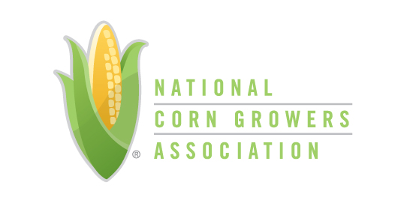
REACHING FOR EXCELLECE: 2017 Applicants

Kansas – Kansas Corn on Campus

Kansas Corn has made an enhanced investment in our education programming. One key component of this was a new presence on college campuses across the state of Kansas. Working with a total of 18 community colleges and seven universities, we have had opportunities to engage with students who are future farmers, industry professionals, politicians, and consumers. All affect the future of corn production. Our Kansas Corn on Campus programs reached into four areas in the launch year: Careers in Corn, Collegiate Corn Academy, Next Generation Scholarship, and Ag Education EPIC Experience. Through these four
programming efforts, Kansas Corn engaged students on campus, supported their educational efforts, connected them with industry professionals and prepared them for their future careers.

Missouri – Corn Talks Trade

With the current administration’s focus on withdrawing or renegotiating NAFTA, Missouri Corn launched a campaign to highlight the importance of trade to our farmers. Outreach efforts also included discussions on increased funding for the Market Access Program (MAP) and Foreign Market Development (FMD) Program. The campaign had three main goals: (1) educate direct stakeholders on trade policy, (2) spur action and finally, (3) deliver proof to our policy makers that trade is vitally important to our farmers. Over the course of 10 events, we collected 1,500 signatures, engaged over 1,000 farmers and industry partners, and delivered a key message to Missouri political leaders.

Minnesota - Innovation Grant Program

Water quality is a significant issue facing Minnesota with agriculture frequently the focal point as a source of nitrogen and phosphorus in surface waters, as well as nitrogen contamination of ground water. The Innovation Grant program was designed to utilize farmer ingenuity in problem solving to provide opportunities for farmers to explore production scale ideas to mitigate nitrogen loss potential from farm fields.

NEBRASKA – Trade Matters Initiative

Nebraska Corn spearheaded a trade matters exhibit for all state agriculture associations (Nebraska Soybean Board, Nebraska Soybean Association, Nebraska Grain Sorghum Board, Nebraska Grain Sorghum Producers, Nebraska Wheat Board, and the Nebraska Wheat Growers Association) to come up with a unifying trade matters message at the 40th Annual Husker Harvest Days.

OHIO – Collegiate Policy Academy

Collegiate leaders from all over the state of Ohio are selected for this program. The 10 that are
selected experience a one-year opportunity of professional development, personal discovery, learn more about Ohio Corn & Wheat and the agricultural industry. Program highlights include: a week in Washington DC, State FFA Convention, Ohio State Fair, Farm Science Review, the Ohio Grain Farmers Symposium, and exclusive networking events. The Collegiate Policy Academy was developed as a part of Ohio Corn & Wheat’s Program of Activities to increase engagement with college students that are interested in agricultural policy, as well as, to build an ambassador team for our student membership. Because of the Collegiate Policy Academy, we have experienced increased competition and higher caliber applicants, more student members, more scholarship applicants, and better connections with interns and young professionals working in the state house as well as in Washington DC.

IOWA – 50th Anniversary Celebration Program

2017 marked the 50th anniversary of the Iowa Corn Growers Association (ICGA). For the last half century, ICGA has been going to bat for Iowa's corn farmers - serving as the collective voice at the state and federal level. Because of our dedicated and engaged membership we have grown into the largest and most influential state corn association.

ICGA knew this was a perfect opportunity to thank our members and celebrate 50 years of accomplishments on behalf of them. This past summer, the District Field Managers (DFM) organized a 50th Anniversary event in each district. Each DFM chose a specific focus area to highlight and build their event around. Focus areas included Research, ICGA past and present leadership, ethanol, livestock, as well as transportation and the Mississippi River locks & dams. The events were also used as recruiting events, as all members were encouraged to bring family, friends, and neighbors to the event.

TEXAS – LAND Program

Leadership. Activism. Networking. Development. Those four words don’t only
make a great farmer-friendly acronym; they are also the four corners on which
the program was built. LAND is a weekend-long commitment for young farm couples.
Participants include those who have recently returned to the farm or have started a new farm business, and are looking to expand their roles on and off the farm. While many other state leadership programs exist, they target more mature farmers with existing leadership skills. LAND fills the void and reignites the excitement of being active in the industry beyond the farm. Not only is it a wonderful learning opportunity for these young farmers, it also allows them an all-expense paid weekend away from the stresses of the farm and family life.

